INSTRUCTIONS FOR ACCESSING THE INTERNET VIA AN ACCESS POINT AT OSPK
1. Turn on Wi-Fi on your device
- Search for a network named PK_Internet:

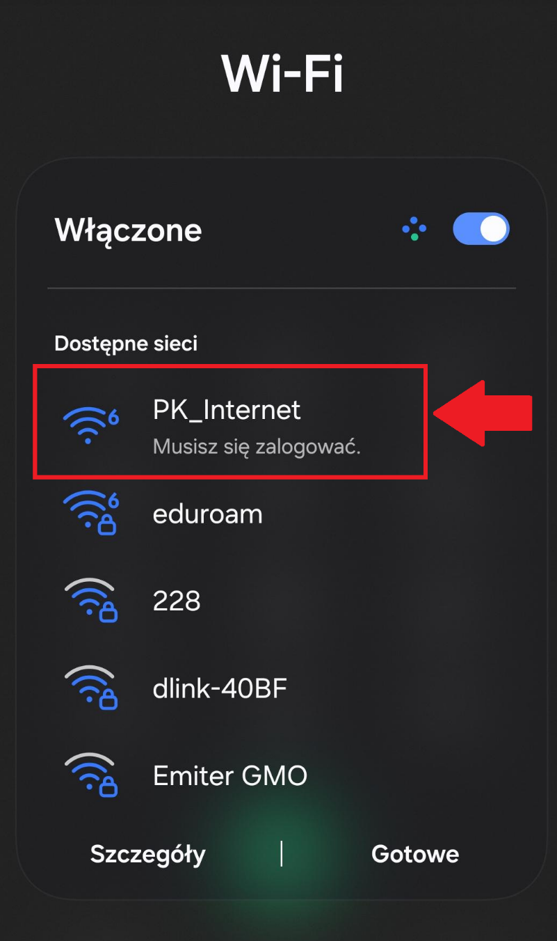

- Once you connect to the PK_Internet network, you should be automatically redirected to the login window, where you’ll need to enter your university email address and the password you use to log in to Microsoft Office MS365
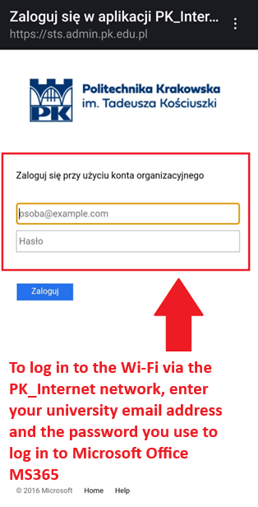

- The PK_Internet network should connect to the device within a few minutes and allow you to access the Internet.

